UM-SJTU Joint Institute

Physics Laboratory

(Vp241)

Laboratory Report

Exercise 4

Polarization of Light

Name: Wenxin He ID: 518370910117 Group: 1

Name: Xiaoxuan Wang ID: 518021910460 Group:1

Date: 22 November 2019

**1. Objective**

The objective of this exercise is to understand some properties of light, in particular

to study the polarization phenomenon and verify Malus' law, as well as to understand the way half- and quarter-wave plates work in optical systems. Generation and detection of elliptically and circularly polarized light will also be investigated.

**2. Theoretical Background**

Light can be described in terms of electromagnetic waves, with the plane of oscillations of the electric field vector (as well as the magnetic field vector) perpendicular to the direction of light propagation. Therefore, light is an example of a transverse wave. For light sources producing the so-called natural light, the emitted light is a random mixture of waves with the electric field vector oscillating in all possible transverse directions. This is due to the randomness of the radiation mechanism. Such natural light is also called unpolarized light. For unpolarized light the distribution of the directions of the electric field vector, in the plane perpendicular to the direction of propagation, is uniform. If the distribution is not uniform, the light is said to be polarized. Studies of the polarization of light played an important role in the development of wave optics. They have resulted in a wide range of applications in numerous areas, such as optical measurement techniques, crystal structure research, and experimental stress analysis.

**2.1 Polarization of Light**

The electric field vector E, which in the context of electromagnetic waves corresponding to the visible part of the spectrum is sometimes referred to as the light vector describes a time-dependent, propagating electric field. In the plane perpendicular to the propagation direction of a light wave, the light vector may have different directions along which its magnitude oscillates. The light, for which the light vector maintains a certain oscillation direction, is called linearly polarized and the axis defining the direction is called the polarization axis **(see Figure 5)**.

The light with the light vector direction rotating about the propagation direction, so that its endpoint traces a circle, is called circularly polarized light. If the vector traces an ellipse, the light said to be elliptically polarized **(see Figure 2)**.

Light emitted from ordinary light sources (natural light) is unpolarized. However, it can be regarded as a statistical equal-weight mixture of linearly polarized waves with

equal amplitudes. There the light may be also partially polarized, which means it can

be regarded as a combination of a polarized and the natural (unpolarized) light. The

direction corresponding to the maximum amplitude of the light vector of such partially polarized light is the oscillation direction of the polarized component.

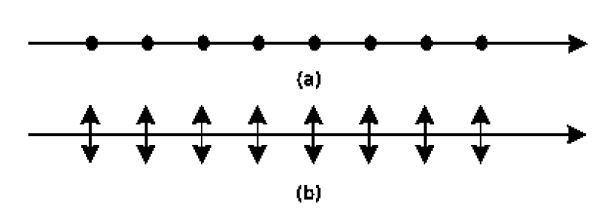

**Figure 1. (a) Linearly polarized light with the polarization axis perpendicular to the page**

**plane. (b) Linearly polarized light with the polarization axis parallel to the page plane.**

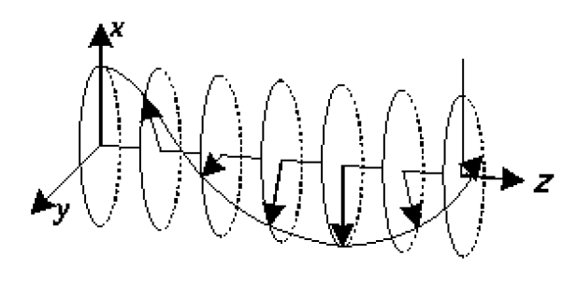

**Figure 2. Elliptically polarized light propagating in the z direction. The light is polarized in the xy plane.**

**2.2 Polarizer**

A device commonly used to produce polarized light is a polaroid (also called a polarizer). It polarizes the light using the principle of dichroism: a selective absorption mechanism tends to allow the light polarized in a certain direction (direction of the crystal alignment) to pass through the material, while the light polarized in all other directions is absorbed. This turns the incident natural light into linearly polarized.

A polarization device can not only change incident natural light to polarized light (it then acts as a polarizer), but may also be used to detect and analyze linearly polarized, natural, and partially polarized light (it is then called an analyzer).

**2.3 Malus’ Law**

A visible effect in the light coming out of a polarization device is a change of the light

brightness.

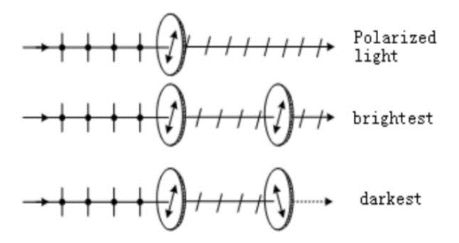

**Figure 3. Change in the brightness of the light depends on the mutual orientation of the polarizer and the analyzer.**

Suppose that we have two polarizers arranged so that their planes are parallel | the

left one plays the role of a polarizer, the other one is an analyzer (see Figure 3). Let the angle between their transmission directions (polarization axes) be _. The light is incident normally on the polarizer and then continues to the analyzer. The intensity of the linearly polarized light leaving the analyzer is

where is the intensity of the linearly polarized light incident on the analyzer. Equation (1), named after Etienne-Louis Malus as the Malus' law, was derived in 1809.

Obviously, for a single polarizer, if polarized light is incident on it, then the transmitted light intensity will change periodically when rotating the polarizer. If the incident light is partially or elliptically polarized, the minimum intensity will not be zero as there will be always some component of the light polarized in the transmission direction. The incident light must be natural or circularly polarized if the intensity does not change at all. Hence, by using a polarizer, one can distinguish linearly polarized light from the natural and circularly polarized light.

**2.4 Generation of Elliptically and Circularly Polarized Light.**

**Half-wave and Quarter-wave Plates**

Suppose that linearly polarized light is incident normally on a crystal plate whose

surface is parallel to its optical axis, and the angle between the polarizing axis and the optical axis of the plate is . Then the linearly polarized light is resolved into two

waves: an e-wave with the oscillation direction parallel to the optical axis of the plate (extraordinary axis) and an o-wave whose oscillation direction is perpendicular to the optical axis (ordinary axis). They propagate in the same direction, but with different speeds. The resulting optical path difference over the thickness d of the plate is and, consequently, the phase difference

where is the wavelength, is the refractive index for the extraordinary axis, and is the refractive index for the ordinary axis. In a so-called positive crystal > 0, whereas in a negative one< 0.

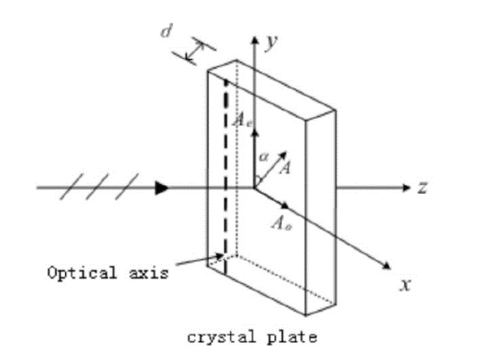

**Figure 4. Linearly polarized light passing through a waveplate.**

As shown in Figure 4, when the light propagates through the crystal plate, the two

components of the light vector are

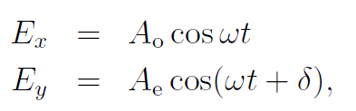

where Ae = Acos, Ao = Asin. Eliminating time from the above equations one obtains

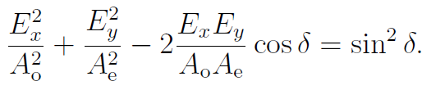

(2)

Note that is the equation of an ellipse for =2.

When the thickness of the plate changes, the optical path difference changes as well.

Some cases of particular interest, are discussed below:

* If = k, where k = 0,1, 2, …, the phase difference = 0, and Eq. (2) reduces to

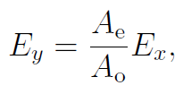

which is a linear equation. Hence the transmitted light is linearly polarized with the

oscillation direction remaining unchanged. A waveplate that satisfies this condition

is called a full-wave plate. The light goes through a full-wave plate without changing

its polarization state.

* If = (2k + 1)/2, where k = 0,1, 2, …, the phase difference = , and Eq. (2)

simplifies to

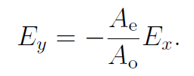

The transmitted light is also linearly polarized with the polarization axis rotated

by the angle of 2. A waveplate that satisfies the condition is called 1/2-wave plate

or half-wave plate. When a polarized light passes through a half-wave plate, its

polarization axis gets rotated by an angle 2. If =4, then the polarization axis

of the transmitted light is perpendicular to that of the incident light.

* Finally, if= (2k + 1)/4, where k = 0, 1, 2, …, the phase difference =2,

and Eq. (2) transforms into

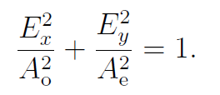

The transmitted light is elliptically polarized. A waveplate that satisfies the above

condition is called a 1/4-wave plate or a quarter-waveplate and is an important

optical element in many polarization experiments.

If Ae = Ao = A, then E^2x + E^2y = A^2, and the transmitted light is circularly polarized.

Since the amplitudes of the o-wave and the e-wave are both functions of , the polarization state after passing through a 1/4-wave plate will vary, depending on the angle:

* if = 0, the transmitted light is linearly polarized with the polarization axis parallel to the optical axis of the 1/4-wave plate;
* if =2, the transmitted light is linearly polarized with the polarization axis perpendicular to the optical axis of the 1/4-wave plate;
* if =4, the transmitted light is circularly polarized;
* Otherwise, the transmitted light is elliptically polarized.

**3. Experimental Setup**

**3.1 Apparatus**

The measurement setup consists of: a semiconductor laser, a tungsten iodine lamp,

a silicon photo-cell, a UT51 digital universal meter, as well as two polarizers, 1/2-wave and 1/4-wave plates (the uncertainty of the angle is 2) and a lens with a glass sheet.

The elements are placed on an optical bench.

**3.2 Device Information**

The information of each measurement device is shown in Table 2.

|  |  |
| --- | --- |
| **apparatus** | **uncertainty** |
| Universal meter |  |
| Polarizer |  |
| Analyzer |  |

**Table 1 Information of Each Measurement Device**

**4. Measurement Procedure**

**4.1 Apparatus Adjustment**

1. Adjust the photo-cell by choosing the appropriate aperture. There are different

apertures on the photo-cell (see the figure below) used in different experiments.

In this experiment, only the 6.0 aperture, which preserves the incident light

intensity, is needed. If other aperture is chosen, the intensity of light may get

reduced, resulting in a zero reading on the universal meter.

Therefore, before proceeding to the next steps, adjust the laser and the photo-cell

so that the light can pass through the 6.0 aperture.

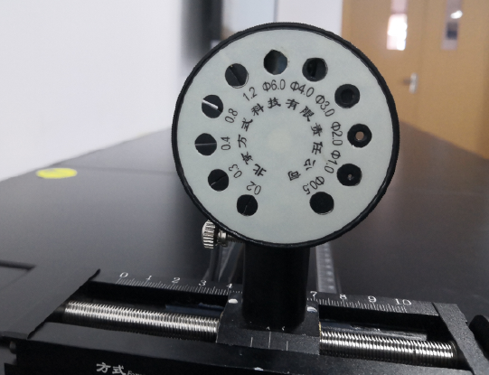

**Figure 5. Photo-cell.**

2. With the laser fixed at one of the ends of the bench, place the lens and the glass sheet in front of it. Make sure that the light passes through the center of the lens.

3. Adjust the distance between the lens and the laser to the focal length of the lens.

4. Move the glass sheet along the bench. If the size of the light spot on the glass varies significantly, repeat Step 2.

5. Remove the glass sheet. Set the digital universal meter in the appropriate mode and range.

**4.2 Demonstration of Malus' Law**

1. Assemble the measurement setup as shown in Figure 6. Make sure that the laser ray passes through the polarizer to generate linearly polarized light before continuing to the analyzer and the silicon photo-cell.

2. Rotate the analyzer for 360and observe a change in the light intensity to find the

maximum electric current I0. At this point, .

3. Rotate the analyzer from 0to 90,record the magnitude of the current I every 5. At the point , the polarizing axes of the polarizer and the analyzer are perpendicular to each other.

4. Record the values in a table and plot the graph I/I0 vs. . Perform linear fitting and compare the data with the theoretical result.

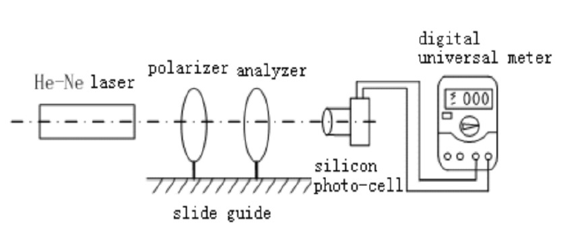

**Figure 6. Experimental setup for a demonstration of Malus' law.**

**4.3 Linearly Polarized Light and the Half-wave Plate**

1. Set up the equipment on the optical bench as shown in Figure 7. A is the analyzer

and P is the polarizer. Set the polarizing axes of A and P perpendicular to each other before placing the 1/2-wave plate in the apparatus; extinction of the light can be observed on screen.

2. After inserting the 1/2-wave plate, rotate it to make the light extinction appear again and set this position as the initial position.

3. Rotate the 1/2-wave plate for = 10 from the initial position and the light extinction will be broken. Then rotate A to make the light extinction appear again,

record the angle of rotation in a table.

4. Rotate the 1/2-wave plate for 10 from the previous position (now = 20) and

repeat Step 3. Repeat this step (increase ) for 8 times. Plot the graph vs..

5. Analyze the data and answer the following questions in this lab report:

(a) How many times can the light extinction be observed when the 1/2-wave plate

rotates for 360?

4 times.

(b) How many times can the light extinction be observed when the analyzer rotates

for 360?

2 times.

(c) Explain the polarization state of linearly polarized light after passing through

the 1/2-wave plate.

A half-wave plate will rotate the polarization axis of a polarized light passing through it by an angle 2. If =4, then the polarization axis of the transmitted light is perpendicular to that of the incident light.

**4.4 Circularly and Elliptically Polarized Light and the 1/4-wave Plate**

1. Set up the equipment on the optical bench as shown in Figure 7. A is the analyzer

and P is the polarizer. Set the polarizing axes of A and P perpendicular to each

other before placing the 1/4-wave plate in the apparatus; extinction of the light can

be observed on screen. At this point the angle = 90.

2. After inserting the 1/4-wave plate, rotate it to make the light extinction appear

again and set this position as the initial position. At this point = 0. Rotate the

1/4-wave plate and observe the change in the light intensity.

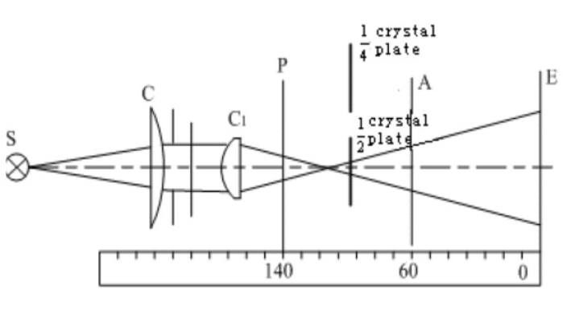i

**Figure 7. Experimental setup for the 1/2-wave plate.**

3. Rotate the analyzer for 360 and record the light intensity (which is indicated by

the current I) for every 10. Record the data in a table.

4. Rotate the 1/4-wave plate for 20, repeat Step 3.

5. Rotate the 1/4-wave plate for 45, repeat Step 3.

6. Rotate the 1/4-wave plate for 70. Then rotate the analyzer and record its position

and the magnitude of the current when the light intensity reaches a maximum.

7. Use a computer to plot the relation between the rotation angle of the analyzer and the light amplitude in polar coordinates. Normalize the amplitude by its maximum value. Mark the position recorded in Step 6 and compare it with the data recorded in Step 4.

Pay attention to the fact that the light intensity is found indirectly by measuring

the electric current, and the intensity is proportional to the amplitude squared. The

current indicates the intensity, not the amplitude.

8. Compare the result of Step 5 with that for the circular polarization. Plot a linear

fit to the data when the angle is 45.

**4.5 Cautions**

* Do not direct the laser beam into the eye.
* Do not touch the surface of the polarizers or the wave plates.
* Please leave the equipment in order before leaving.

**5. Results**

**5.1 Malus’ Law Demonstration**

|  |  |  |  |
| --- | --- | --- | --- |
| Maximum Electric Current 1.145 | | | |
|  | I[] |  | I[] |
| 0 | 1.144 | 50 | 0.508 |
| 5 | 1.140 | 55 | 0.416 |
| 10 | 1.114 | 60 | 0.331 |
| 15 | 1.109 | 65 | 0.234 |
| 20 | 1.032 | 70 | 0.165 |
| 25 | 0.994 | 75 | 0.092 |
| 30 | 0.906 | 80 | 0.045 |
| 35 | 0.808 | 85 | 0.013 |
| 40 | 0.714 | 90 | 0.000 |
| 45 | 0.613 |  |  |

**Table 2 Measurement data Malus’ law demonstration**

We want to find the relationship between and I/, the following calculation uses the example of and I=1.140.

We arrange all the results in Table 3:

|  |  |  |  |  |  |
| --- | --- | --- | --- | --- | --- |
|  | I[] |  |  |  |  |
| 0 | 1.144 | 1.000 | 0.000 | 0.999 | 0.001 |
| 5 | 1.140 | 0.992 | 0.006 | 0.996 | 0.001 |
| 10 | 1.114 | 0.970 | 0.01 | 0.973 | 0.001 |
| 15 | 1.109 | 0.933 | 0.02 | 0.969 | 0.001 |
| 20 | 1.032 | 0.883 | 0.02 | 0.901 | 0.001 |
| 25 | 0.994 | 0.821 | 0.03 | 0.868 | 0.001 |
| 30 | 0.906 | 0.750 | 0.03 | 0.791 | 0.001 |
| 35 | 0.808 | 0.671 | 0.03 | 0.706 | 0.001 |
| 40 | 0.714 | 0.587 | 0.03 | 0.624 | 0.001 |
| 45 | 0.613 | 0.500 | 0.04 | 0.535 | 0.001 |
| 50 | 0.508 | 0.413 | 0.03 | 0.444 | 0.001 |
| 55 | 0.416 | 0.329 | 0.03 | 0.363 | 0.0009 |
| 60 | 0.331 | 0.250 | 0.030 | 0.289 | 0.0009 |
| 65 | 0.234 | 0.179 | 0.03 | 0.204 | 0.0009 |
| 70 | 0.165 | 0.117 | 0.02 | 0.144 | 0.0009 |
| 75 | 0.092 | 0.067 | 0.02 | 0.080 | 0.0009 |
| 80 | 0.045 | 0.030 | 0.01 | 0.039 | 0.0009 |
| 85 | 0.013 | 0.008 | 0.006 | 0.011 | 0.0009 |
| 90 | 0.000 | 0.000 | 0.000 | 0.000 | 0.0009 |

**Table 3 Calculation of and I/I0**

Then we apply linear fit to vs. , shown in Figure 8.

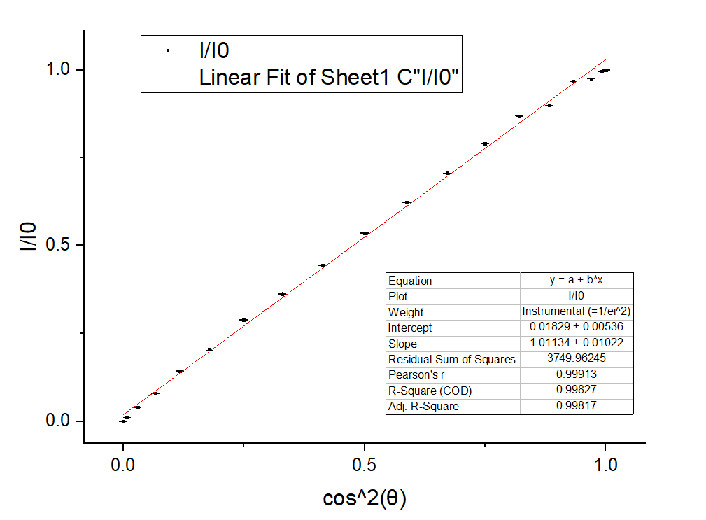­

**Figure 8 Linear fit of I/I0 vs cos^2(θ)**

From the figure we can see that the Pearson’s r is 0.999 and the intercept is close to 0, which means is proportional to . The slope is 1.01134, and the theoretical value of the slope should be 1. The relative error is , which is very small.

**5.2 Linearly Polarized Light and the Half-wave Plate**

|  |  |  |
| --- | --- | --- |
| Rotation angle of the 1/2-wave plate | Recorded angle of the analyzer | Rotation angle of the analyzer |
| Initial | 195 | 0 |
| 10 | 215 | 20 |
| 20 | 235 | 40 |
| 30 | 253 | 58 |
| 40 | 272 | 77 |
| 50 | 293 | 98 |
| 60 | 312 | 117 |
| 70 | 331 | 136 |
| 80 | 350 | 155 |
| 90 | 11 | 176 |

**Table 3 Measurement data for the 1/2-wave plate**

For the rotation angle of the analyzer, we need to perform the following calculation, taking 215 as an example:

Then we apply linear fit to , shown in Figure 9.

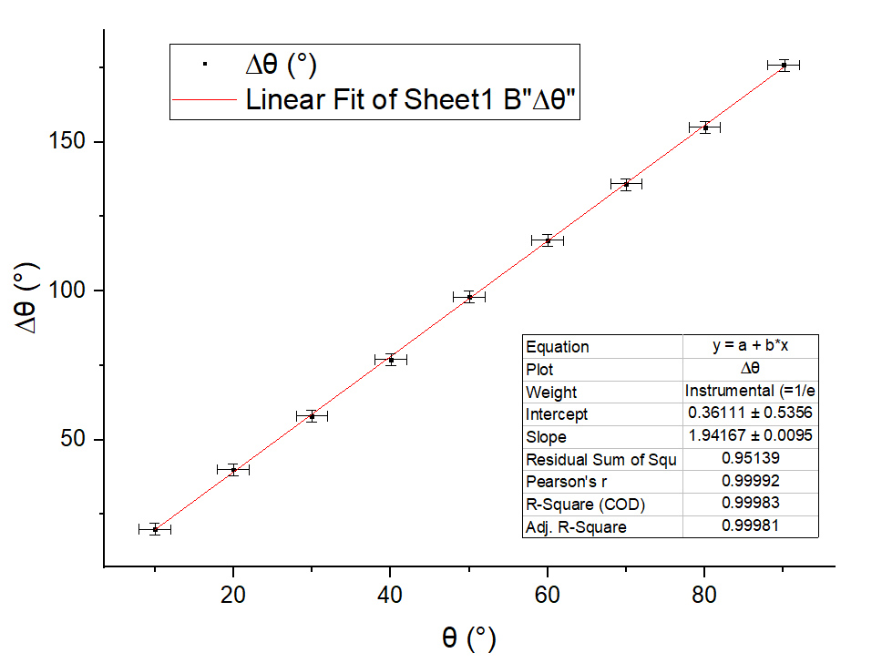

**Figure 9 Linear fit of Δθvs θ**

From the figure we can see that the Pearson’s r is 0.999 which is very close to 1, and the intercept is 0.36 which is very close to 0. These mean that . The slope is 1.94 The theoretical value of the slope should be 2. The relative error is , which is very small.

**5.3 Circularly and Elliptically Polarized Light and the 1/4-wave Plate**

**5.3.1 Rotation angle 0**

|  |  |  |  |
| --- | --- | --- | --- |
| Maximum Electric Current =0.825 | | | |
|  | I[] |  | I[] |
| 0 | 0.793 | 180 | 0.782 |
| 10 | 0.727 | 190 | 0.737 |
| 20 | 0.614 | 200 | 0.657 |
| 30 | 0.455 | 210 | 0.539 |
| 40 | 0.299 | 220 | 0.412 |
| 50 | 0.181 | 230 | 0.283 |
| 60 | 0.084 | 240 | 0.151 |
| 70 | 0.016 | 250 | 0.055 |
| 80 | 0.001 | 260 | 0.004 |
| 90 | 0.000 | 270 | 0.007 |
| 100 | 0.019 | 280 | 0.075 |
| 110 | 0.081 | 290 | 0.181 |
| 120 | 0.223 | 300 | 0.324 |
| 130 | 0.367 | 310 | 0.470 |
| 140 | 0.495 | 320 | 0.599 |
| 150 | 0.617 | 330 | 0.716 |
| 160 | 0.717 | 340 | 0.796 |
| 170 | 0.768 | 350 | 0.825 |

**Table 4 Measurement data for the 1/4-wave plate of rotation angle**

We want to find the relationship between and

Take I=0.793for example,0.0009

We calculate all the results, shown in Table5:

|  |  |  |  |  |  |
| --- | --- | --- | --- | --- | --- |
| Maximum Electric Current =0.825 | | | | | |
|  |  |  |  |  |  |
| 0 | 0.980 | 0.0009 | 180 | 0.974 | 0.0009 |
| 10 | 0.939 | 0.0009 | 190 | 0.945 | 0.0009 |
| 20 | 0.863 | 0.0009 | 200 | 0.892 | 0.0009 |
| 30 | 0.743 | 0.0009 | 210 | 0.808 | 0.0009 |
| 40 | 0.602 | 0.001 | 220 | 0.707 | 0.001 |
| 50 | 0.468 | 0.001 | 230 | 0.586 | 0.001 |
| 60 | 0.319 | 0.002 | 240 | 0.428 | 0.001 |
| 70 | 0.139 | 0.004 | 250 | 0.258 | 0.002 |
| 80 | 0.035 | 0.02 | 260 | 0.070 | 0.009 |
| 90 | 0.000 | / | 270 | 0.092 | 0.007 |
| 100 | 0.152 | 0.004 | 280 | 0.302 | 0.002 |
| 110 | 0.313 | 0.002 | 290 | 0.468 | 0.001 |
| 120 | 0.520 | 0.001 | 300 | 0.627 | 0.0010 |
| 130 | 0.667 | 0.001 | 310 | 0.755 | 0.0009 |
| 140 | 0.775 | 0.0009 | 320 | 0.852 | 0.0009 |
| 150 | 0.865 | 0.0009 | 330 | 0.932 | 0.0009 |
| 160 | 0.932 | 0.0009 | 340 | 0.982 | 0.0009 |
| 170 | 0.965 | 0.0009 | 350 | 1.000 | 0.0009 |

**Table 5 Calculation of sqrt(I/I0)**

Then we plot in the polar coordinate, shown in Figure 10.

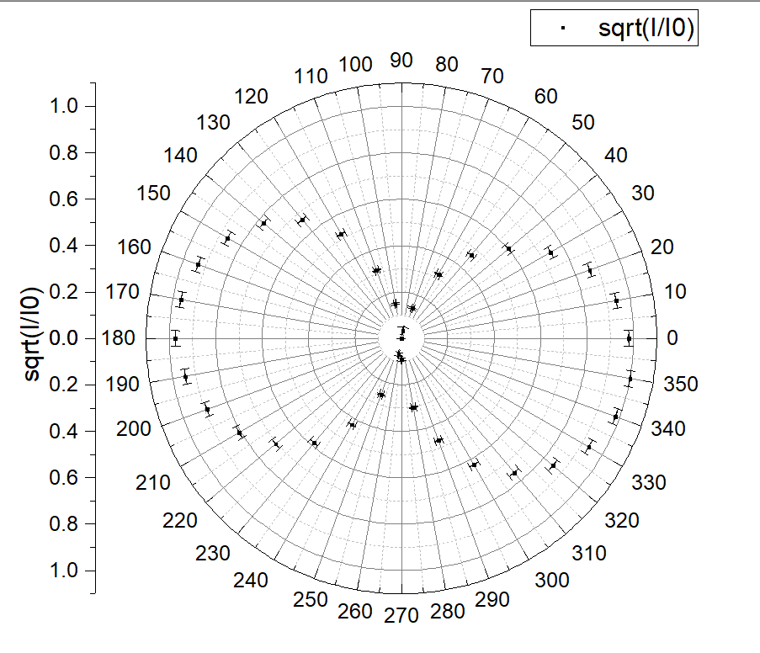

**Figure 10 Plot of sqrt(I/I0) vs θ**

**5.3.2 Rotation angle 20**

|  |  |  |  |
| --- | --- | --- | --- |
| Maximum Electric Current =0.686 | | | |
|  | I[] |  | I[] |
| 0 | 0.655 | 180 | 0.593 |
| 10 | 0.686 | 190 | 0.652 |
| 20 | 0.678 | 200 | 0.664 |
| 30 | 0.636 | 210 | 0.637 |
| 40 | 0.548 | 220 | 0.588 |
| 50 | 0.447 | 230 | 0.522 |
| 60 | 0.345 | 240 | 0.420 |
| 70 | 0.253 | 250 | 0.321 |
| 80 | 0.183 | 260 | 0.228 |
| 90 | 0.175 | 270 | 0.151 |
| 100 | 0.122 | 280 | 0.104 |
| 110 | 0.097 | 290 | 0.105 |
| 120 | 0.103 | 300 | 0.137 |
| 130 | 0.145 | 310 | 0.212 |
| 140 | 0.218 | 320 | 0.302 |
| 150 | 0.334 | 330 | 0.399 |
| 160 | 0.441 | 340 | 0.503 |
| 170 | 0.528 | 350 | 0.598 |

**Table 6 Measurement data for the 1/4-wave plate of rotation angle**

We want to find the relationship between and

Take I=0.793for example,0.001

We calculate all the results, shown in Table7:

|  |  |  |  |  |  |
| --- | --- | --- | --- | --- | --- |
| Maximum Electric Current =0.686 | | | | | |
|  |  |  |  |  |  |
| 0 | 0.977 | 0.001 | 180 | 0.930 | 0.001 |
| 10 | 1.000 | 0.001 | 190 | 0.975 | 0.001 |
| 20 | 0.994 | 0.001 | 200 | 0.984 | 0.001 |
| 30 | 0.963 | 0.001 | 210 | 0.964 | 0.001 |
| 40 | 0.894 | 0.001 | 220 | 0.926 | 0.001 |
| 50 | 0.807 | 0.001 | 230 | 0.872 | 0.001 |
| 60 | 0.709 | 0.001 | 240 | 0.782 | 0.001 |
| 70 | 0.607 | 0.001 | 250 | 0.684 | 0.001 |
| 80 | 0.516 | 0.001 | 260 | 0.577 | 0.001 |
| 90 | 0.505 | 0.001 | 270 | 0.469 | 0.002 |
| 100 | 0.422 | 0.002 | 280 | 0.389 | 0.002 |
| 110 | 0.376 | 0.002 | 290 | 0.391 | 0.002 |
| 120 | 0.387 | 0.002 | 300 | 0.447 | 0.002 |
| 130 | 0.460 | 0.002 | 310 | 0.556 | 0.001 |
| 140 | 0.564 | 0.001 | 320 | 0.664 | 0.001 |
| 150 | 0.698 | 0.001 | 330 | 0.763 | 0.001 |
| 160 | 0.802 | 0.001 | 340 | 0.856 | 0.001 |
| 170 | 0.877 | 0.001 | 350 | 0.934 | 0.001 |

**Table 7 Calculation of sqrt(I/I0)**

Then we plot in the polar coordinate, shown in Figure11.

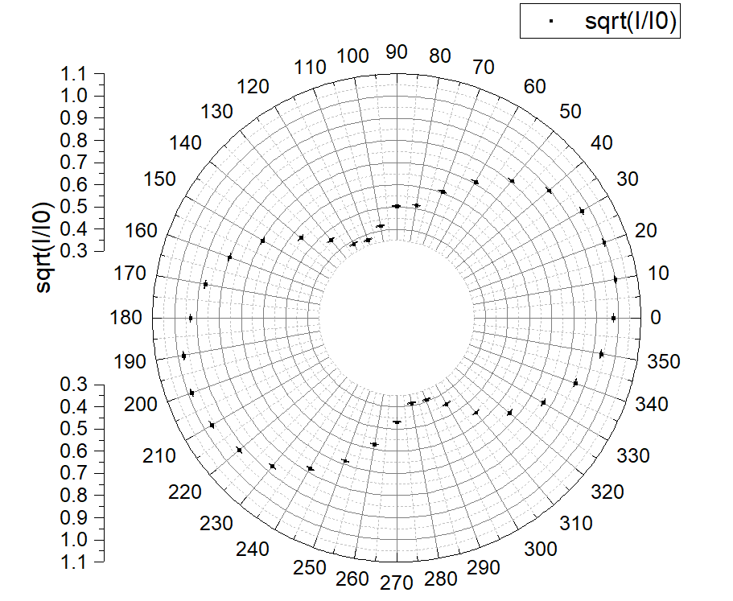

**Figure 11 Plot of sqrt(I/I0) vs θ**

**5.3.3 Rotation angle 45**

|  |  |  |  |
| --- | --- | --- | --- |
| Maximum Electric Current =0.432 | | | |
|  | I[] |  | I[] |
| 0 | 0.389 | 180 | 0.373 |
| 10 | 0.397 | 190 | 0.380 |
| 20 | 0.404 | 200 | 0.387 |
| 30 | 0.412 | 210 | 0.396 |
| 40 | 0.417 | 220 | 0.410 |
| 50 | 0.418 | 230 | 0.424 |
| 60 | 0.420 | 240 | 0.428 |
| 70 | 0.422 | 250 | 0.432 |
| 80 | 0.423 | 260 | 0.428 |
| 90 | 0.420 | 270 | 0.423 |
| 100 | 0.412 | 280 | 0.422 |
| 110 | 0.403 | 290 | 0.406 |
| 120 | 0.392 | 300 | 0.394 |
| 130 | 0.382 | 310 | 0.390 |
| 140 | 0.374 | 320 | 0.384 |
| 150 | 0.369 | 330 | 0.382 |
| 160 | 0.368 | 340 | 0.383 |
| 170 | 0.369 | 350 | 0.386 |

**Table 8 Measurement data for the 1/4-wave plate of rotation angle**

We want to find the relationship between and

Take I=0.793for example,0.002

We calculate all the results, shown in Table9:

|  |  |  |  |  |  |
| --- | --- | --- | --- | --- | --- |
| Maximum Electric Current =0.432 | | | | | |
|  |  |  |  |  |  |
| 0 | 0.949 | 0.002 | 180 | 0.929 | 0.002 |
| 10 | 0.959 | 0.002 | 190 | 0.938 | 0.002 |
| 20 | 0.967 | 0.002 | 200 | 0.946 | 0.002 |
| 30 | 0.977 | 0.002 | 210 | 0.957 | 0.002 |
| 40 | 0.982 | 0.002 | 220 | 0.974 | 0.002 |
| 50 | 0.984 | 0.002 | 230 | 0.991 | 0.002 |
| 60 | 0.986 | 0.002 | 240 | 0.995 | 0.002 |
| 70 | 0.988 | 0.002 | 250 | 1.000 | 0.002 |
| 80 | 0.990 | 0.002 | 260 | 0.995 | 0.002 |
| 90 | 0.986 | 0.002 | 270 | 0.990 | 0.002 |
| 100 | 0.977 | 0.002 | 280 | 0.988 | 0.002 |
| 110 | 0.966 | 0.002 | 290 | 0.969 | 0.002 |
| 120 | 0.953 | 0.002 | 300 | 0.955 | 0.002 |
| 130 | 0.940 | 0.002 | 310 | 0.950 | 0.002 |
| 140 | 0.930 | 0.002 | 320 | 0.943 | 0.002 |
| 150 | 0.924 | 0.002 | 330 | 0.940 | 0.002 |
| 160 | 0.923 | 0.002 | 340 | 0.942 | 0.002 |
| 170 | 0.924 | 0.002 | 350 | 0.945 | 0.002 |

**Table 9 Calculation of sqrt(I/I0)**

Then we plot in the polar coordinate, shown in Figure 12.

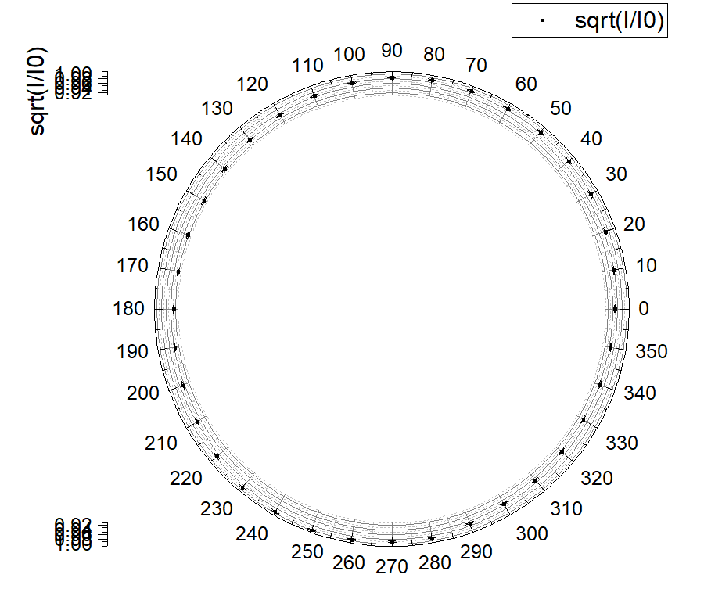

**Figure 12 Plot of sqrt(I/I0) vs θ**

**5.3.4 Rotation angle 70**

When the current reaches its maximum, we recorded the angle of the analyzer and the current in Table10:

|  |  |
| --- | --- |
| θ | 65 |
|  | 0.699 |

**Table 10 Measurement data for the 1/4 wave-plate of rotation angle 70°**

In this case,.

Since in the previous steps, we record the data from 90°,therefore, in this case, θ of the transmitted light should be 65+90=145°correspondingly. We compare the result with the result of the 1/4-wave plate of the rotation angle 20°when the current reaches its maximum, shown in Table11:

|  |  |  |
| --- | --- | --- |
|  | Rotation angle 70 | Rotation angle 20 |
| θ | 145 | 10 |
| Imax[] | 0.699 | 0.686 |
|  | 1 | 1 |

**Table 11 Comparison of angle 70°and angle 20°**

We also mark the maximum current point on the previous plot of 1/4-wave plate of the rotation angle 20°, shown in Figure13:

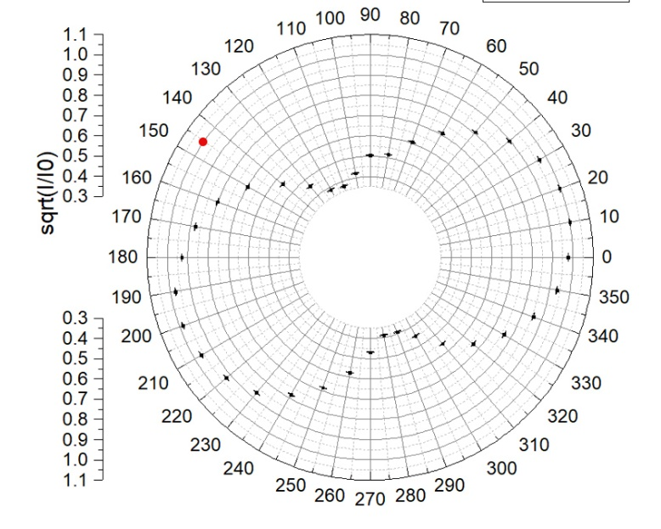

**Figure 13 Marked position**

**6. Conclusions and discussion**

**6.1 Conclusions**

In this lab, we understand some properties of light. Particularly, we study the polarization phenomenon and verify Malus' law, as well as understand the way half- and quarter-wave plates work in optical systems. Generation and detection of elliptically and circularly polarized light are also be investigated.

**6.1.1 Malus’ Law**

We apply linear fit to vs . The result shows that the Pearson’s r is 0.999 and the intercept is close to 0, which means is proportional to . The slope is 1.01134, which is very close to the theoretical value 1, with the relative error.

From the result we verify Malus’ Law:.

**6.1.2 Linearly Polarized Light**

We apply linear fit to The result shows that the Pearson’s r is 0.999 which is very close to 1, and the intercept is 0.36 which is very close to 0. These mean that . The slope is 1.94he theoretical value 2 with the relative error.

This means that the polarization axis of a polarized light passing through the half-wave plate is rotated by an angle 2 .

**6.1.3 Circularly and Elliptically Polarized Light**

**6.1.3.1 Wave-plate Rotation angle=0°**

Observing the polar plot of , we can see that there are two maximum light intensity near 0 and 180two light extinction near 0 and 270. Since the minimum intensity is zero, so in this case, the transmitted light is linearly polarized. Its polarization axis is parallel to the optical axis of the ¼ wave plate.

**6.1.3.2 Wave-plate Rotation angle=20°**

Observing the polar plot of , we can see that there are two maximum light intensity near 20 and 200two light intensity minimums near and 290, In this case, the transmitted light is elliptically polarized.

**6.1.3.3 Wave-plate Rotation angle=45°**

Observing the polar plot of , there is no light extinction, and the maximum and minimum light intensity are about the same. When is changing, the light intensity changes slightly. In this case, the transmitted light is circularly polarized.

**6.1.3.4 Wave-plate Rotation angle=70°**

Observing the marked position on Figure13, we find that at the symmetric position of the red spot about 180°is the maximum light intensity point of the 1/4-wave plate of rotation angle 20°. From table11 we can see that the two maximum current are almost the same.

We conclude that when rotation angles are complementary, the position where the light intensity reaches its maximum are symmetric about 180°. The maximum light intensity is also the same.

**6.1.3.5 Comparison among the different angles of the wave-plate**

When the angle of the wave-plate is rotated ，the angles of the analyzer when the light intensity maximum and minimum are reached increase by

When the rotation angle is increasing from 0°to 45°, the maximum light intensity is decreasing.

**6.2 Error Analysis**

* Environment light will largely affect the result of this experiment.
* It is hard to make sure that the light passes through the center of the lens.
* We cannot ensure that the light is incident normally on the polarizer and the analyzer.
* The readings of the universal meter are unstable. The same angle may not result in the same light intensity at a second time.
* The uncertainty of the angle is relatively large.
* There are fingerprints and other stains on the surface of the plate and analyzer, which may cause error when the light is polarized.
* Since the light intensity is indirectly found by measuring the electric current, there might be errors in the process of transforming the two factors.

**6.3 Improvements**

* Do this experiment in a completely dark environment.
* Use digital device to record the angle of the analyzer, so that the uncertainty of the angle can be reduced.

**7. Reference**

[1] M. Krzyzosiak (2019). Exercise 4 - lab manual [rev. 5].pdf Shanghai: UMJI-SJTU.

**A. Measurement uncertainty analysis**

**A.1 Uncertainty in Demonstration of Malus’ Law**

**A.1.1 Uncertainty in Calculation of**

Here we use the radian system for the angle.

Take for example,

**A.1.2 Uncertainty in Calculation of**

Take I=1.144 for example,

**A.2 Uncertainty in Analysis of 1/4-wave plate**

**A.2.1 Rotation angle 0**

Take I=0.793 for example,

We calculate all the uncertainties:

|  |  |  |  |  |  |
| --- | --- | --- | --- | --- | --- |
| Maximum Electric Current =0.825 | | | | | |
|  | I[] |  |  | I[] |  |
| 0 | 0.793 | 0.0009 | 180 | 0.782 | 0.0009 |
| 10 | 0.727 | 0.0009 | 190 | 0.737 | 0.0009 |
| 20 | 0.614 | 0.0009 | 200 | 0.657 | 0.0009 |
| 30 | 0.455 | 0.0009 | 210 | 0.539 | 0.0009 |
| 40 | 0.299 | 0.0011 | 220 | 0.412 | 0.0010 |
| 50 | 0.181 | 0.0013 | 230 | 0.283 | 0.0011 |
| 60 | 0.084 | 0.0019 | 240 | 0.151 | 0.0014 |
| 70 | 0.016 | 0.0044 | 250 | 0.055 | 0.0024 |
| 80 | 0.001 | 0.0174 | 260 | 0.004 | 0.0087 |
| 90 | 0.000 | / | 270 | 0.007 | 0.0066 |
| 100 | 0.019 | 0.0040 | 280 | 0.075 | 0.0020 |
| 110 | 0.081 | 0.0019 | 290 | 0.181 | 0.0013 |
| 120 | 0.223 | 0.0012 | 300 | 0.324 | 0.0010 |
| 130 | 0.367 | 0.0010 | 310 | 0.470 | 0.0009 |
| 140 | 0.495 | 0.0009 | 320 | 0.599 | 0.0009 |
| 150 | 0.617 | 0.0009 | 330 | 0.716 | 0.0009 |
| 160 | 0.717 | 0.0009 | 340 | 0.796 | 0.0009 |
| 170 | 0.768 | 0.0009 | 350 | 0.825 | 0.0009 |

**Table 12 Uncertainty of rotation angle 0°**

**A.2.2 Rotation angle 20**

Take I=0.655 for example,

We calculate all the uncertainties:

|  |  |  |  |  |  |
| --- | --- | --- | --- | --- | --- |
| Maximum Electric Current =0.686 | | | | | |
|  | I[] |  |  | I[] |  |
| 0 | 0.655 | 0.001 | 180 | 0.593 | 0.001 |
| 10 | 0.686 | 0.001 | 190 | 0.652 | 0.001 |
| 20 | 0.678 | 0.001 | 200 | 0.664 | 0.001 |
| 30 | 0.636 | 0.001 | 210 | 0.637 | 0.001 |
| 40 | 0.548 | 0.001 | 220 | 0.588 | 0.001 |
| 50 | 0.447 | 0.001 | 230 | 0.522 | 0.001 |
| 60 | 0.345 | 0.001 | 240 | 0.420 | 0.001 |
| 70 | 0.253 | 0.001 | 250 | 0.321 | 0.001 |
| 80 | 0.183 | 0.001 | 260 | 0.228 | 0.001 |
| 90 | 0.175 | 0.001 | 270 | 0.151 | 0.002 |
| 100 | 0.122 | 0.002 | 280 | 0.104 | 0.002 |
| 110 | 0.097 | 0.002 | 290 | 0.105 | 0.002 |
| 120 | 0.103 | 0.002 | 300 | 0.137 | 0.002 |
| 130 | 0.145 | 0.002 | 310 | 0.212 | 0.001 |
| 140 | 0.218 | 0.001 | 320 | 0.302 | 0.001 |
| 150 | 0.334 | 0.001 | 330 | 0.399 | 0.001 |
| 160 | 0.441 | 0.001 | 340 | 0.503 | 0.001 |
| 170 | 0.528 | 0.001 | 350 | 0.598 | 0.001 |

**Table 13 Uncertainty of rotation angle 20°**

**A.2.3 Rotation angle 45**

Take I=0.389 for example,

We calculate all the uncertainties:

|  |  |  |  |  |  |
| --- | --- | --- | --- | --- | --- |
| Maximum Electric Current =0.432 | | | | | |
|  | I[] |  |  | I[] |  |
| 0 | 0.389 | 0.002 | 180 | 0.373 | 0.002 |
| 10 | 0.397 | 0.002 | 190 | 0.38 | 0.002 |
| 20 | 0.404 | 0.002 | 200 | 0.387 | 0.002 |
| 30 | 0.412 | 0.002 | 210 | 0.396 | 0.002 |
| 40 | 0.417 | 0.002 | 220 | 0.41 | 0.002 |
| 50 | 0.418 | 0.002 | 230 | 0.424 | 0.002 |
| 60 | 0.420 | 0.002 | 240 | 0.428 | 0.002 |
| 70 | 0.422 | 0.002 | 250 | 0.432 | 0.002 |
| 80 | 0.423 | 0.002 | 260 | 0.428 | 0.002 |
| 90 | 0.420 | 0.002 | 270 | 0.423 | 0.002 |
| 100 | 0.412 | 0.002 | 280 | 0.422 | 0.002 |
| 110 | 0.403 | 0.002 | 290 | 0.406 | 0.002 |
| 120 | 0.392 | 0.002 | 300 | 0.394 | 0.002 |
| 130 | 0.382 | 0.002 | 310 | 0.39 | 0.002 |
| 140 | 0.374 | 0.002 | 320 | 0.384 | 0.002 |
| 150 | 0.369 | 0.002 | 330 | 0.382 | 0.002 |
| 160 | 0.368 | 0.002 | 340 | 0.383 | 0.002 |
| 170 | 0.369 | 0.002 | 350 | 0.386 | 0.002 |

**Table 14 Uncertainty of rotation angle 45°**

